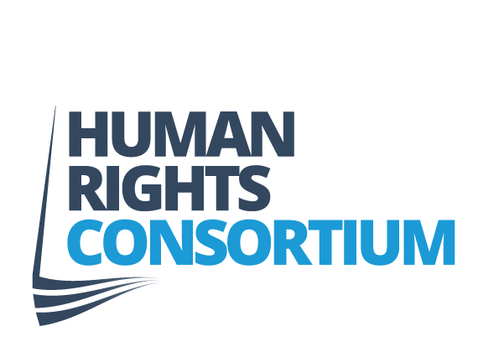

Human Rights Advocacy & Research Officer

Job Description
Job Title:
Human Rights Advocacy & Research Officer
Location:
Human Rights Consortium, Community House, 6A Albert Street, Belfast (with hybrid options available).
Hours:
Full-time, 35 hours per week
Duration: 18 Months starting March 2026 with possibility of extension subject to receipt of funding.
Reports to:
Director
Salary:
NJC Scales SO1, Points 23 to 25 (£34,434 to £36,363). Successful candidates will usually start at the bottom of this scale.
Pension: The Consortium makes an 8% (of salary) pension commitment to each staff member.
Leave: 30 days annually plus statutory holidays. Leave year 1st April to 31st March.
Overall Purpose of the Job
The Human Rights Campaigner/Researcher will take a leading role in delivering the Consortium’s campaign to secure a Bill of Rights for Northern Ireland, the incorporation and protection of international human rights standards into law, the full realisation of the human rights commitments of the Belfast/Good Friday Agreement and the long term adherence with those standards in the governance of Northern Ireland. This role combines strategic campaigning, research, and stakeholder engagement to build public, political, and civil society support for these objectives.
The post-holder will:
- Lead on research and evidence development to underpin advocacy efforts.
- Design and implement campaign activities, including public engagement, political lobbying, events and member mobilisation.
- Produce high-quality publications, briefing papers, and digital content to communicate the benefits of a rights-based framework.
- Work collaboratively with Consortium members, partners, and policymakers to advance the campaign vision.

Main Responsibilities
- Campaign Leadership
- Drive delivery of the campaign plan, including flagship reports, Westminster briefings, manifesto templates, and public narrative tools.
- Coordinate member engagement activities and develop practical toolkits to support participation.
- Organise events, webinars, and media opportunities to amplify campaign messages.

- Research & Analysis
- Conduct research on governance, social and economic rights, and comparative international examples.
- Produce evidence-based reports, briefing papers, and policy recommendations.
- Monitor developments in human rights law and policy relevant to Northern Ireland.

- Advocacy & Communications
- Develop clear, accessible messaging for diverse audiences.
- Prepare and deliver presentations, social media content, and microsite updates.
- Engage with political representatives, civil society, and media to promote campaign objectives.

- Collaboration & Networking
- Build and maintain relationships with Consortium members, academics, and advocacy partners.
- Represent the Consortium at external meetings and events.
- Facilitate working groups and roundtables on thematic issues (e.g., UN treaties, ECHR protection).

- General
- Ensure all work reflects the Consortium’s commitment to equality, diversity, and non-partisanship.
- Undertake other research and campaign activities in line with the strategic focus and objectives of the Human Rights Consortium when needed.
- Undertake other duties consistent with the role as required.

Person Specification
Essential Criteria
- Experience:
- Minimum 5 years’ experience in a similar role involving human rights campaigning, research, and advocacy.
- Proven track record of delivering successful campaigns and producing high-quality research outputs.

- Knowledge:
- Strong understanding of domestic, regional, and international human rights instruments.
- Familiarity with Northern Ireland’s political and governance context.
- Knowledge of modern communication and digital campaigning techniques.

- Skills:
- Excellent research, analytical, and writing skills.
- Strong interpersonal and networking abilities.
- Ability to manage multiple priorities, work independently, and meet deadlines.
- Competence in digital tools for campaign delivery (social media, video editing, digital design, microsites, etc.).

- General:
- Commitment to human rights and equality.
- Ability to work in a non-partisan way with all sections of society.
- Willingness to travel within NI and occasionally to GB/Ireland.

Desirable Criteria
- Experience in legislative advocacy or influencing policy change.
- Knowledge of UN treaty mechanisms and incorporation processes.
- Understanding of the community, voluntary, and statutory sectors in NI.

