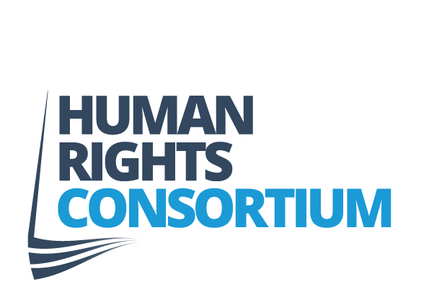
JOB DESCRIPTION

JOB TITLE | Human Rights Officer (Campaigns and Membership) Maternity Cover
LOCATION | Human Rights Consortium, First Floor, Community House, Citylink Business Park, 6A Albert Street, Belfast, BT12 4HQ.
REPORTS TO | Director
RESPONSIBLE FOR | Volunteers and Interns
SALARY | £28,221 (pensionable) Fixed Term position (7 months) May to November 2019 (Maternity Cover)
HOURS PER WEEK | 35

OVERALL PURPOSE OF THE JOB

The Human Rights Officer (Campaigns and Membership) is responsible for developing and implementing the Human Rights Consortium’s campaign activity to achieve its aim of a strong and inclusive Bill of Rights for Northern Ireland.

The job of the Human Rights Officer (Campaigns and Membership) is to contribute to the longer-term campaign strategy, but to be particularly responsible for implementing the campaign on an ongoing basis, working with member organisations of the Consortium to establish, achieve and review campaign objectives. The Campaign Officer should be able to suggest creative approaches to making the campaign effective.

The Human Rights Officer will have particular responsibility for motivating and involving member organisations to support campaigning objectives.

The Human Rights Officer will be responsible for co-ordinating our lobbying activities, including meetings with political parties, governments and opinion formers and for playing a leading role in our external communications.

1. MAIN RESPONSIBILITIES:

- To contribute to the campaign strategy for a strong and inclusive Bill of Rights.

- To implement the agreed programme of campaigning and advocacy activities.

- To develop external communications, including production of publications, website and media relations, in conjunction with any internal communications staff or external communications consultants.

- To take a lead on campaign communications and engagement with the Consortium membership.

- To coordinate campaigns on an ongoing basis, ensuring that activities are on course and that appropriate people are involved inside and outside the Consortium.

- To undertake activities in support of the campaign e.g. organising meetings, lobbying events, demonstrations, and/ or attending relevant external events and meetings on behalf of the Consortium.
- To provide support, training and advice to Consortium members and act as the main point of contact with the Consortium membership.

- To deliver all aspects of this job description in accordance with good equal opportunities practice.

- To undertake other duties which are in line with the general level of responsibility of the post.

PERSON SPECIFICATION
Human Rights Officer – Campaigns and Membership

CRITERIA | Essential | Desirable
Experience  Two – three years’ experience of: | Organising campaigns  Advocacy/lobbying on specific issues  Experience of working with a range of people inside and outside own organisation to achieve objectives | Campaigning on human rights issues  Organising events, seminars and conferences
Knowledge | Knowledge of a range of modern communication techniques  Knowledge of parliamentary and political processes | Knowledge of international and domestic human rights instruments  Knowledge of the Bill of Rights debate in Northern Ireland
Skills | Interpersonal skills, ability to communicate effectively on a one to one basis and in groups, at all levels of an organisation  Organisational skills, ability to work flexibly and move between tasks  Ability to prioritise own work and manage conflicting deadlines  Creativity, ability to innovate  Ability to work unsupervised and use initiative  Excellent oral and written communication skills
General | Commitment to human rights and equality  Commitment to work in a non-partisan way with all sections of society  Prepared to travel locally and internationally | Understanding of the community, voluntary and statutory sector in Northern Ireland

